Lab Assignment:6.4

Name: Sushanth

H.no:2403A51348

Batch:14

TASK Description#1

Start a Python class named Student with attributes name, roll_number, and marks. Prompt GitHub Copilot to complete methods for displaying details and checking if marks are above  
average.

Code:

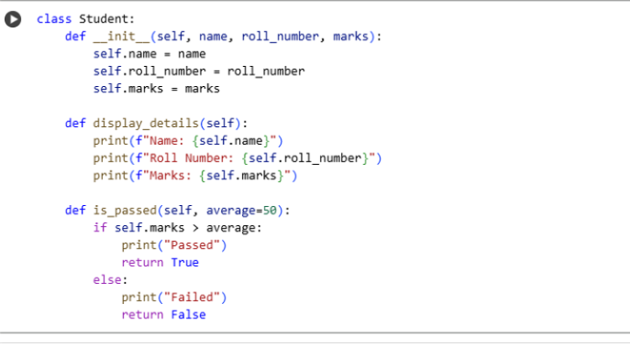

Output:

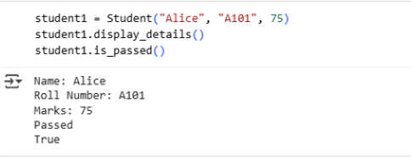

OBSERVATION:

1.The Student class has three attributes: name, roll_number, and marks.

2.The display_details() method prints the student's details.

3.The is_passed() method checks if the student's marks are above a given average (default 50) and prints/returns the result using an if-else condition.

TASK Description#2

Write the first two lines of a for loop to iterate through a list of numbers. Use a comment prompt to let Copilot suggest how to calculate and print the square of even numbers only.

Code:

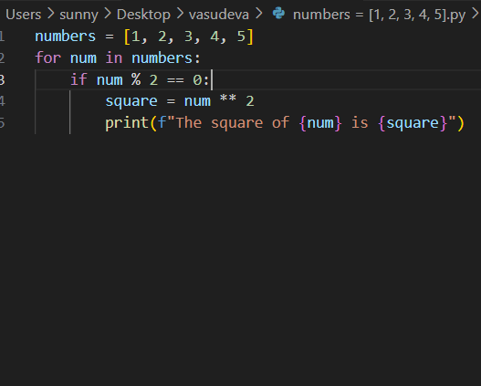

Output:

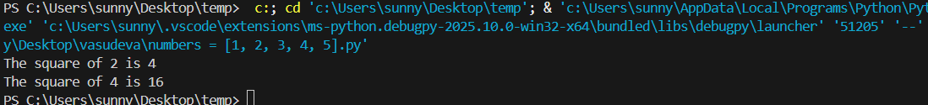

OBSERVATION:

1.Write the first two lines of a for loop to iterate through a list of numbers. Use a comment  
2.prompt to let Copilot suggest how to calculate and print the square of even numbers only.

3. To calculate and it will print the square of even numbers.

TASK Description#3

Create a class called BankAccount with attributes account_holder and balance. Use Copilot to complete methods for deposit(), withdraw(), and check for insufficient balance.

Code:

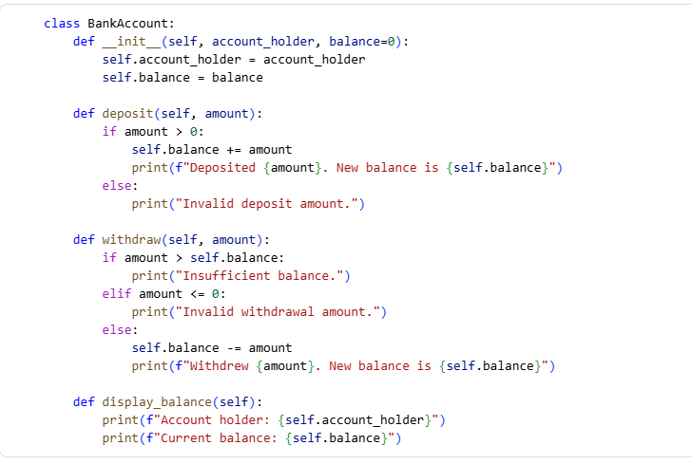

Output:

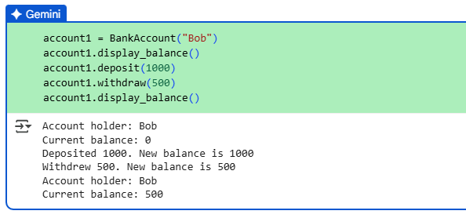

Observation:

1.deposit(): Adds to balance if amount is positive.

2.withdraw(): Checks for insufficient balance and valid amount, then subtracts.

3.display_balance(): Shows account holder and current balance.

TASK Description#4

Define a list of student dictionaries with keys name and score. Ask Copilot to write a while  
loop to print the names of students who scored more than 75.

Code:

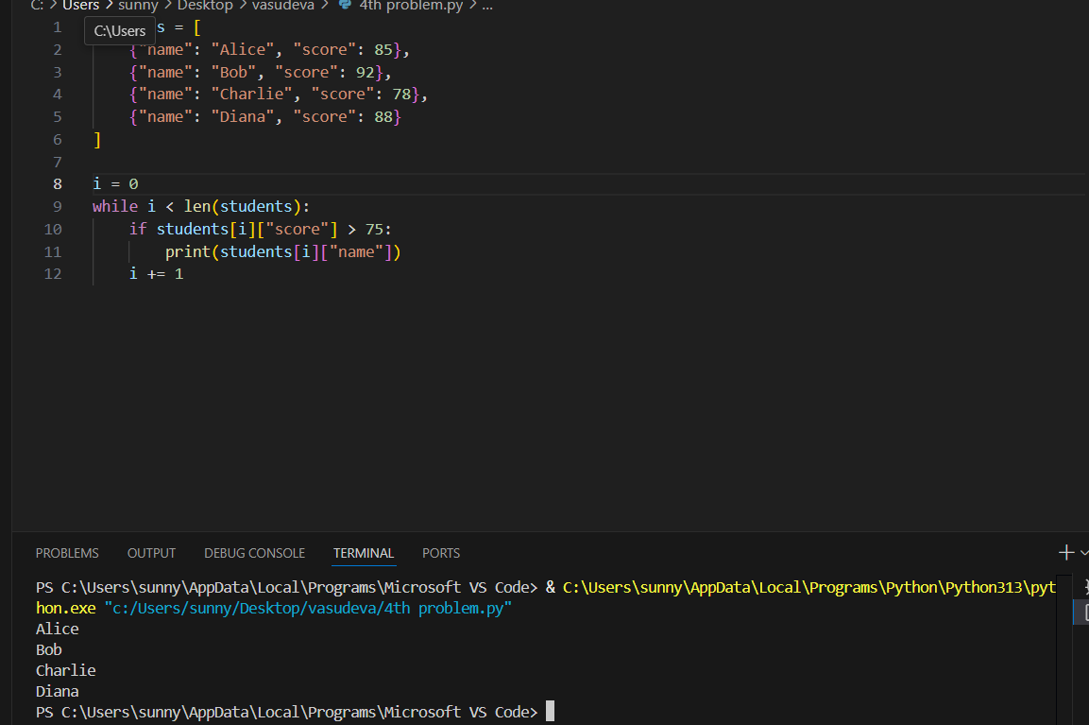

Observation:

1.This while loop iterates over the list of students.

2.For each student, if their score is greater than 75, their name is printed

3. it will print the names of students who scored more than 75.

TASK Description#5

Begin writing a class ShoppingCart with an empty items list. Prompt Copilot to generate methods to add_item, remove_item, and use a loop to calculate the total bill using conditional discounts.

Code:

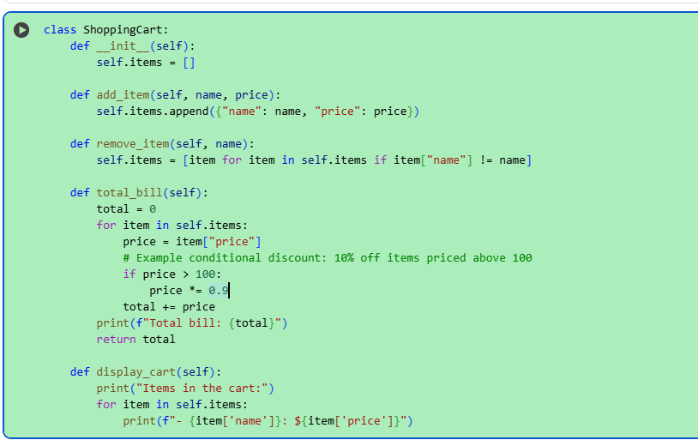

Output:

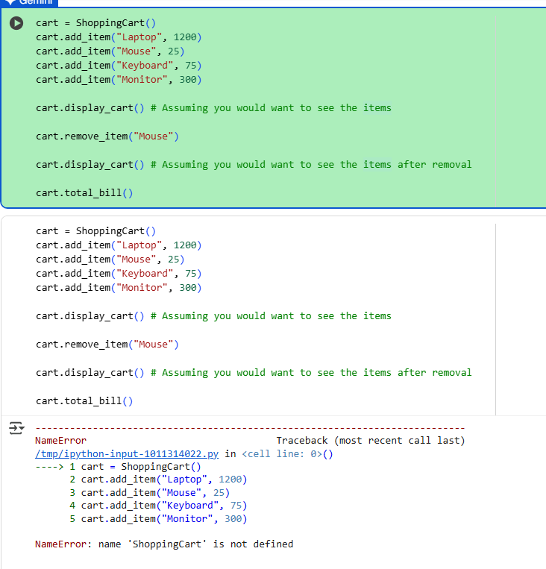

Observation:

* add_item(name, price): Adds an item to the cart.
* remove_item(name): Removes item(s) by name.
* total_bill(): Loops through items, applies a 10% discount to items over 100, sums total, and prints the bill.You can adjust the discount logic as needed.